**Tableau- Superstore State & Segment wise PivotTable**

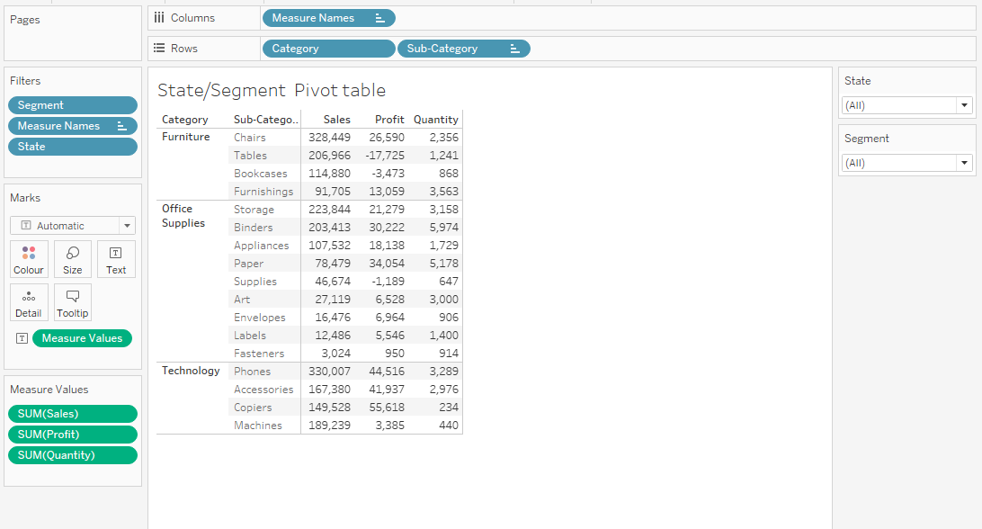

**Superstore State_& Segment wise Visualization**

